
SHIRE HIGHLANDS EDUCATION DIVISION
2026 MALAWI SCHOOL CERTIFICATE OF EDUCATION MOCK
EXAMINATION

TECHNICAL DRAWING

Subject Number: M201/II
Thursday, 12 March Time Allowed: 2 hour 40 min
8:00-10:40 am
PAPER II
(100 marks)
ORTHOGRAPHIC DRAWING
(ENGINEERING DRAWING)
Instructions
- The working time for this paper is 2 hours and 30 minutes. An addditional time of ten minutes is allowed at the beginning of the examination for reading through the paper.

- This papers contains 3 printed pages with section A and B. please check.

- Write your NAME on the bottom right- hand- corner of your drawing sheet.

- Answer the question in section A one one side and section B on the other side of the drawing sheet

- Section A carries 15 marks and section B carries 85 marks

- All dimensions are in millimeters.

SECTION A (15 marks)
- Draw neat free hand sketches to show the following:
- Internal vee thread (3 marks)

- Wing nut (3 marks)
- Split pin (3 marks)

- Double headed feather key (3 marks)

- lug (3 marks)

Section B (85 marks)
- The drawing on page 3 shows details of a SWIVEL MACHINE drawn in first angle orthographic projection.
With the parts correctly assembled, draw full size, in either first angle or third angle orthographic projection the following views:
- A sectional front elevation on the cutting line P-P (40 marks)
- Plan.
(Hidden details are to be shown on the plan only) (15 marks)
- An end view (18 marks)
- Insert the following dimensions (i) the overall height (ii) overall length (iii) any diameter (6 marks)
- In a title block 110m x 40mm high and then print: (i) the title SWIVEL MACHINE in letters 6mm high
(ii) the scale used in letters 4mm high
(iii) indicate, with an appropriate symbol, the type of projection used. (6 marks)
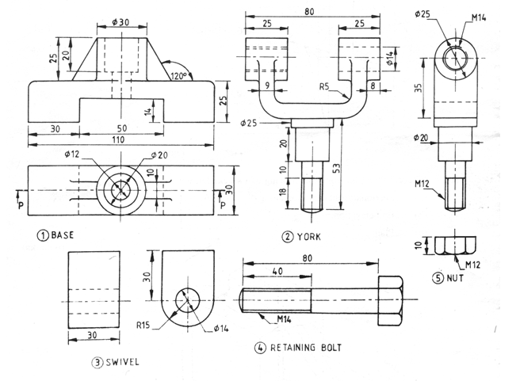

END OF QUESTION PAPER
NB: This paper contains 3 printed pages

